Calum Sutton
HLTA – Computing / ICT
Media Balance & Wellbeing
Privacy & Security
Digital Footprint & Identity
Relationships & Communication
Cyberbullying, Digital Drama & Hate Speech
News & Media Literacy
High Well School
Online Safety & Digital Literacy

Helping young people take ownership of their digital lives.
Technology is often a catalyst for good, but it can have real human costs. Parents, teachers, the media, and even the leaders of the tech companies themselves are expressing growing concerns about the role tech may play in the social and emotional well-being of young people. Young people are on the front lines of a digital revolution. Devices, social networks, and media are changing childhood in radical ways. We all want everyone to grow up healthy and happy as the world accelerates around them.
All pupils need digital citizenship skills to participate fully in their communities and make smart choices online and in life. Our lessons in online safety and digital literacy aim to;
- Address top concerns for schools and parents.
- Prepare pupils with critical 21st-century skills to safely navigate a digital world.
- Understand how to use social media positively but also identify the risks.
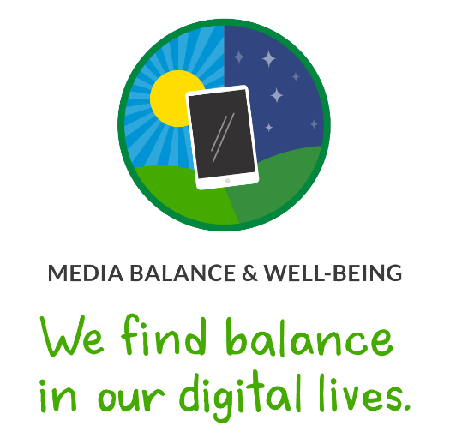

Overview
Today, we live in a world overflowing with digital media and technology. All of us, adults and young people, have constant access to real-time information from around the globe but do the benefits of being ever-connected also come with risks to our mental health? It's an important question to ask; especially for our children. Our Media Balance & Well-Being lessons give pupils the space to reflect on their own media use. Plus, they'll get the tools they need to think critically about how digital media affects our communities and society overall.

Our Instructional Approach

Emotional Learning
To support pupils in developing an internal sense of "media balance," our lessons prompt pupils to reflect on the different feelings and emotions that arise when they engage in activities that involve digital media (streaming TV shows, playing online games, and so on). Some pupils may need additional support and practice in recognising and interpreting these emotions. For example, prolonged social media use may result in a mix of positive and negative emotions. Pupils will need to think through these different emotional reactions to eventually draw conclusions about what "balanced" use means for them.

Balance
In our lessons on this topic, we do not use the term "addiction" in reference to device or digital media use. While we know that young people and adults are using their devices a lot (research even tells us they feel "addicted") there's no official diagnosis for "device addiction" or consensus around what this phrase means. Moreover, the line between healthy and harmful use varies person to person and context to context (with evidence showing that already vulnerable teens, for instance, are more likely to exhibit unhealthy use of media) and research shows both positive and negative impacts of everything from social media to games.
Our lessons focus on agency, not addiction, and quality time, not screen time. This means encouraging pupils to reflect on their own media diets and to develop individual plans for healthy media balance that consider both how media contributes productively and unproductively to their lives and relationships, and to grow the former and reduce the latter.

Lessons in this topic:

Your Rings of Responsibility
How do digital citizens take responsibility for themselves, their communities, and their world?

My Media Choices
What makes a healthy media choice?

Finding My Media Balance
What does media balance mean for me?

Finding Balance in a Digital World
How do we balance digital media use in our lives?

My Media Use: A Personal Challenge
What is your strategy for finding media balance?

Digital Media and Your Brain
How does digital media try to hook you, and what can you do about it?

My Digital Life Is Like ...
What is the role of digital media in our lives?

Social Media and How You Feel
How can you use social media in a way that feels positive and healthy?

Can Media Be Addictive?
Are we addicted to our devices, and, if so, are companies to blame?

The Health Effects of Screen Time
Can screen time be bad for us?

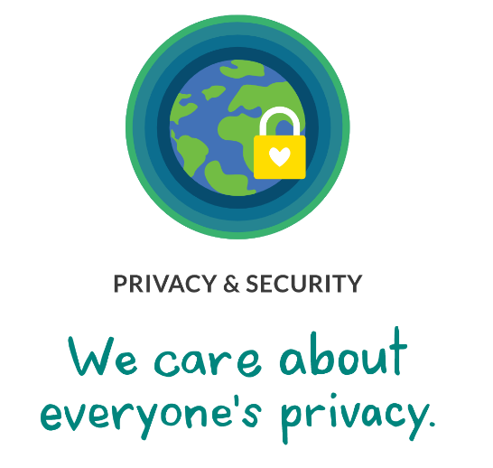

Overview
This topic introduces pupils to the concept of online privacy and the potential implications of sharing private information with a range of people: friends, the public, app providers, and more. Sharing information about yourself can be a natural and healthy activity, and it can lead to positive connections and personal growth. However, it can also present safety risks, and pupils need to be aware of potentially harmful consequences such as identity theft and financial exploitation.

Our Instructional Approach

Balance of Benefits and Risks
On this topic, it is easy to default to scary rhetoric about the dangers of "Big Brother" and "stranger danger." However, a balanced approach looks at both the rewards and risks of sharing information online with others. Our lessons highlight some of the amazing opportunities that pupils have to interact, grow, and learn from each other. They also seek to prepare students to have a reasonable and cautious awareness of the serious risks associated with engaging in online activity, both from strangers and from third-party providers. Pupils will learn concrete strategies for safe, appropriate digital interactions so they can minimise the risks of online sharing and take advantage of the rewards.

Real-Life Scenarios
To help pupils see the importance of being safe and secure when they're online, our lessons include real-life scenarios where private information could potentially be shared, and where the benefits and risks are notable but not sensationalised. From encountering clickbait to setting up passwords to messaging with people online, the scenarios in lessons provide an authentic context for grappling with the potential dangers that come with spending time online.

Lessons in this topic:

Password Power-Up
How can a strong password help protect your privacy?

Private and Personal Information
What information about you is OK to share online?

You Won't Believe This!
What is clickbait and how can you avoid it?

Don't Feed the Phish
How can you protect yourself from phishing?

Big, Big Data
How do companies collect and use data about you?

Being Aware of What You Share
How can you protect your privacy when you're online?

The Big Data Dilemma
What are the benefits and drawbacks of online tracking?

Risk Check for New Tech
What privacy risks do new technologies present, and how do we decide if they're worth it?

How Young Is Too Young for Social Media?
At what age should people be allowed to use social media?

Debating the Privacy Line
Should the government have access to all your social media and mobile data?

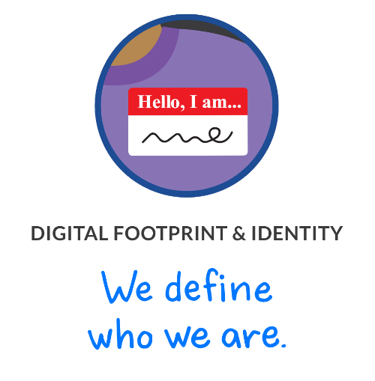

Overview
In a time of 24/7 connectivity, do the benefits of online sharing outweigh the risks? Lessons will prompt pupils to consider how sharing information online can affect them and others and will support them in learning to reflect before they reveal, as well as encourage others to do the same. Pupils will also learn the pros and cons of having different personas and explore how presenting themselves differently online can affect their sense of self, their reputations, and their relationships.

Our Instructional Approach

Self-Awareness
Pupils will reflect on the most important parts of their identities and how they relate to their activities online. Because of the complex nature of identity formation and the unique developmental process that all individuals go through, pupils will have a wide range of responses and awareness levels related to what makes up their identities. Some pupils will benefit from additional support to recognise the biggest influences in their lives and what they deem most important.

Group Associations (Gender, Race, and Class)
Pupils will explore the influence of stereotypes over their identities and specifically, gender stereotypes. Pupils will be prompted to respond to different statements about gender and to consider their meanings. While the goal of these lessons is to get pupils talking and thinking about common stereotypes associated with "boy" and "girl," and with the notion of gender generally. Pupils will be encouraged to move beyond that discussion and focus on the potentially negative impact that stereotypes can have on people's identities and on how they treat others.

Lessons in this topic:

This Is Me
How does what I post online affect my identity?

Our Online Tracks
How does our online activity affect the digital footprints of ourselves and others?

Beyond Gender Stereotypes
How do gender stereotypes shape our experiences online?

Who Are You Online?
What are the benefits and drawbacks of presenting yourself in different ways online?

The Power of Digital Footprints
What is a digital footprint, and what does yours convey?

Social Media and Digital Footprints: Our Responsibilities
How does using social media affect our digital footprints?

Protecting Online Reputations
How can you respect the privacy of others online?

Curated Lives
How can I create a social media presence that represents the real me?

Who's Looking at Your Digital Footprint?
How can information you post online affect your future opportunities?

The Change You Want to See
How can you create a digital footprint that showcases your purpose?

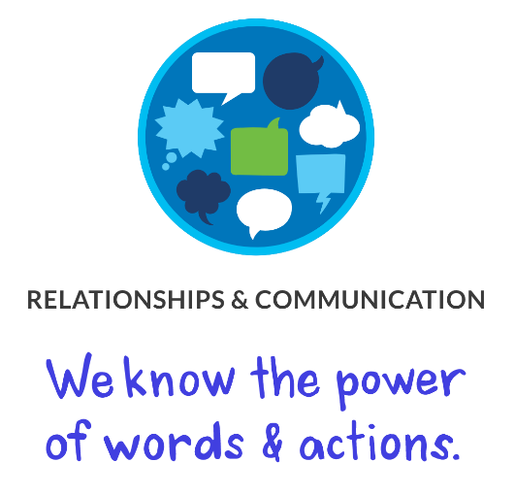

Overview
As the line between online and offline continues to blur, pupils reflect on how they can use intrapersonal and interpersonal skills to build and strengthen positive online communication and communities. They will explore common digital stressors and their influences on relationships. Pupils will also gain an understanding of how to communicate effectively online and how and why some topics and conversations can best lend themselves to certain mediums.

Our Instructional Approach

Beyond Online Predators
The term "online predator" often conjures up the image of a creepy older man at a computer screen waiting to lure an unsuspecting child. The media reinforces this depiction, which is problematic because it does not fit with the kinds of risky relationships that are more common for young people. In reality, when online sexual solicitation does occur, it's more likely to be between two teens or between a teen and a young adult. Young people need support getting clarity on this misconception and with distinguishing myth from reality when it comes to online sexual solicitation.

Boundaries
Through real-life scenarios and first-person testimonials, pupils get a chance to practice setting boundaries they're comfortable with. From sexting to grooming to controlling, pupils learn about the potentially unhealthy behaviours that can result from online relationships.

Lessons in this topic:

Our Digital Citizenship Pledge
What makes a strong online community?

Keeping Games Fun and Friendly
How can I be positive and have fun while playing online games, and help others do the same?

Digital Friendships
How do you keep online friendships safe?

Chatting Safely Online
How do you chat safely with people you meet online?

My Social Media Life
How does social media affect our relationships?

Sexting and Relationships
What are the risks and potential consequences of sexting?

Chatting and Red Flags
How can you tell when an online relationship is risky?

Rewarding Relationships
How can I make sure my relationships are positive and healthy?

Connecting with Digital Audiences
How can we use code-switching to enhance our communication with online audiences?

We Are Civil Communicators
How can we communicate with civility online?

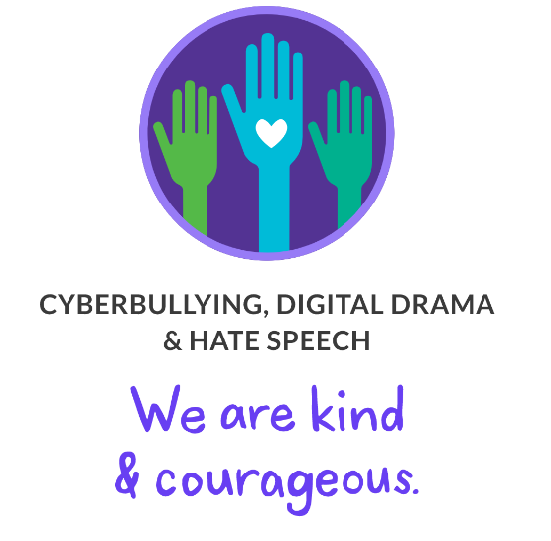

Overview
Lessons on this topic will teach pupils about the effects of digital drama, cyberbullying, and hate speech on both themselves and their larger communities. They will explore the roles people play and how individual actions, negative and positive, intentional and unintentional, can affect their peers and their broader communities. They are encouraged to take the active role of upstander and build positive, supportive online communities, and they will learn how to cultivate empathy, compassion, and courage to combat negative interactions online.

Our Instructional Approach

A Spectrum of Behaviour
Pupils will examine different types of unkind language to develop an understanding of what distinguishes unkindness from cyberbullying, digital drama, and hate speech, including how each issue affects others and the required responses for each.
While these types of language have meaningful differences, they also overlap, and pupils will need support to distinguish among them. The difference between cyberbullying and hate speech, for example, is not just the specific words that are used but the context in which they are used, the relationship between the people involved, the frequency of use, and potentially many other factors.

A Safe Space
Pupils will be exposed to the important, but sensitive, topic of hate speech. Through direct engagement with specific examples of hate speech, pupils will develop an understanding of what distinguishes it from other kinds of hurtful language and will explore productive ways to respond to it.
Because hate speech is intended to elicit strong emotional reactions from those who hear it, pupils are likely to find these examples offensive and uncomfortable. This is an important but challenging part of examining and confronting this type of language when it appears.

Lessons in this topic:

The Power of Words
What should you do when someone uses mean or hurtful language on the internet?

Be A Super Digital Citizen
How can we be upstanders when we see cyberbullying?

Is It Cyberbullying?
What is cyberbullying and what can you do to stop it?

Digital Drama Unplugged
How can you de-escalate digital drama so it doesn't go too far?

Upstanders and Allies: Taking Action Against Cyberbullying
How can you respond when cyberbullying occurs?

Responding to Online Hate Speech
How should you respond to online hate speech?

What You Send In "That Moment When ... "
How can we act with empathy and positivity when we're online?

Countering Hate Speech Online
How can we counter online hate speech and xenophobia?

Online Disinhibition and Cyberbullying
How does online disinhibition sometimes lead to cyberbullying?

Should Online Hate Speech Be Censored?
Should online hate speech be censored?

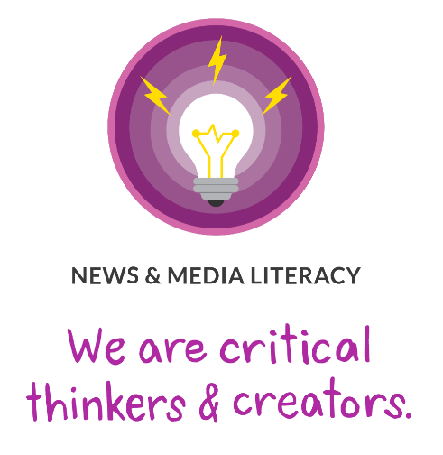

Overview
It's essential that pupils learn to think critically about the news and media they encounter every day. Pupils will demonstrate the ability to identify, evaluate, and use information effectively, find credible and trustworthy sources, and give proper credit. They will recognise how individuals and society are influenced by the media and the misrepresentations and stereotypes they sometimes promote. Pupils will reflect on their responsibilities and rights as creators in the online spaces where they consume, create, and share information.

Our Instructional Approach

Beyond Credible Sources
The current world of news media (both internet-based and otherwise) requires pupils to have a critical, but not cynical, eye. Our lessons seek to help them develop a critical lens, but not by disavowing the knowledge and experiences that they already bring to the table. Personal experiences can help pupils stay critically engaged, particularly when the source is social media or a news outlet with a particular point of view.

Fairness
We all have our favourites when it comes to where we get our news and entertainment media. These favourites can reflect who we are: our personality, our gender, our cultural background, our age. The goal of these lessons is to help pupils find and use their favourite news and media sources more effectively and critically. Our lessons address this issue without creating or implying a hierarchy of credible news sources. When pupils are affirmed in their choices and in who they are; they are much more likely to grow and learn.

Lessons in this topic;

Is Seeing Believing?
Why do people alter digital photos and videos?

A Creator's Rights and Responsibilities
What rights and responsibilities do you have as a creator?

Reading News Online
What are the important parts of an online news article?

Finding Credible News
How do we find credible information on the internet?

The Four Factors of Fair Use
What rights to fair use do you have as a creator?

This Just In!
How should we react to breaking news?

Hoaxes and Fakes
How can you avoid being fooled by fake videos and other information online?

Challenging Confirmation Bias
How can we challenge our own confirmation bias?

Clicks for Cash
How does internet advertising contribute to the spread of misinformation?

Filter Bubble Trouble
How can filter bubbles limit the information we're exposed to?

