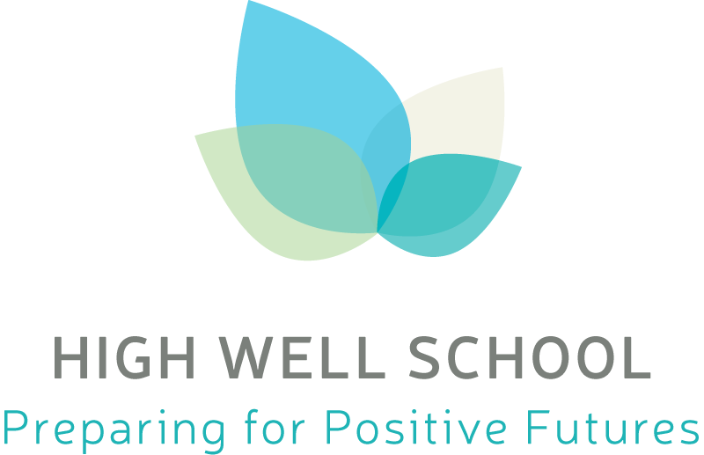

Pupil Premium Review 2018/19

- Review of expenditure
Previous Academic Year |  | 2018/19Total PP Budget 39,270
Desired outcome | Chosen action/approach | Estimated impact: Did you meet the success criteria? Include impact on pupils not eligible for PP, if appropriate. | Lessons learned  (and whether you will continue with this approach) | Cost
All Year 11 pupils leave HWS with a qualification in Mathematics & English and have secured Post 16 provision  Reduction in the number of pupils classified as NEET compared to 2017/18 | Bespoke packages of support including1:1 tuition and vocational provision put in place for CiC and PP pupils at KS4 who are not engaging with/attending education on the school site  Fortnightly access to Connexions PA for independent CEAIG  Bespoke transition plan for each pupil to ensure appropriate Post 16 provision is secured | 78% of pupils left with a qualification in English and Mathematics. Qualifications included ELC3 Functional Skills Levels 1 & 2 and GCSE.  2 pupils achieved GCSEs in English and Mathematics.  4 pupils achieved GCSE Mathematics.  89% of pupils achieved a place in Post 16 provision in a range of settings.  78% pupils had taken up their chosen places as of October 2019  Post 16 College 4  Training Provider 1  Apprenticeship 1  Employment 1  NEET 2 | Bespoke packages of support will remain available for pupils whose needs cannot be addressed fully as part of whole school/class provision  The school has ceased its contract with Prospects and secured a new experienced Careers Advisor through and SLA with a local MAT. Pupils will have weekly access to independent CEAIG in Year 11  The school in conjunction with Wakefield College have commissioned a transition taster course for Year 11 pupils 2019/20 which will run weekly from September 2019 to April 2020 to provide better preparation for moving from specialist to mainstream provision Post 16 | £25,674
Desired outcome | Chosen action/approach | Estimated impact: Did you meet the success criteria? Include impact on pupils not eligible for PP, if appropriate. | Lessons learned  (and whether you will continue with this approach) | Cost  £30,647
Reduce persistent absence for PP and CiC to 50% by July 2019 | Increase the hours of attendance officer post from 27.5 to 34 hours per week to increase availability for home visits and meeting with professionals  Review current attendance system and processes to ascertain how they impact on the attendance of pupils in hard to reach families  Raise the profile of attendance across the school with a whole school focus on promoting ‘Good Attendance’ in Spring & Summer terms 2018/19  Analyse data to identify a target cohort of pupils whose attendance could be moved from PA to non-PA by July 2018  Analyse current and historic data to identify a target cohort of hard to reach families  Working with families identify barriers preventing ‘good attendance’ and assess whether a multi-agency approach is required  Create a personalised plan for each family addressing barriers and setting appropriate targets to improve attendance | Criteria was not met across the school. Most impact was seen in Years 7&8 however Year 9 also demonstrate a reduction in PA.  Impact of the work to increase attendance and reduce persistent absence can most clearly be seen at KS3 reflecting the high priority and relentless focus on improving attendance.  The improvements clearly support the rationale for appointment of the Attendance Officer in September 2017 and subsequent increase in hours in September 2018. The impact of improved attendance in KS3 is expected to be sustained as those pupils move through school. The changing culture in the school community towards understanding the importance of good attendance should have on long term outcomes, including at the end of KS4.  Year 7  100% of PP pupils improved their attendance from starting point  Year 7 Attendance July 18 Attendance July 19  PP 72.80% 86.00%  PA PP 51.20% 75.83%  CiC 100% 97.89%  PA% 50% 50%  Year 8  63% PP pupils improved their attendance from their starting point  Year 8 Average Attendance July 17 or starting date Average Attendance July 19  PP 65.39% 80.30%  PA PP 60.83% 79.34%  CiC 71.79 50.79  PA% 90% 36.36%  Year 9  69.23% of pupils improved attendance from starting point  Year 9 Average Attendance July 16 or starting date Average Attendance July 19  PP 48.55% 54.76%  PA PP 48.55 54.76%  CiC 67.00% 25.23%  PA% 100% 67.30% | Initial target of reducing PA across the school for PP & CiC to 50% was not focused enough and did not take into account entrenched behaviours in relation to attendance at KS4.  Future targets to be set for year groups rather than whole school which will allow more focused intervention to take place.  The Attendance Officer post and increase in hours will continue to be funded through pupil premium given the impact at KS3 and change in culture in the school.  EEF Guide to Pupil Premium: low attendance is a barrier to success in school. Increasing attendance across the school will continue to be a focus for 2019/20 and beyond.

