



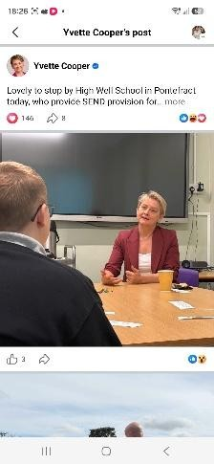

Designated Safeguarding Lead:

Mr M Richardson

Safeguarding Officer:

M
iss S Shaw

Social Care Direct Tel:

503 503/
0845 8

01924 303465

High Well School

Rookhill Road, Pontefract, WF8 2DD

E:
admin@highwell.org.uk

T:
01924 572 100

Interim
Headteacher:
Mr M Richardson

19
th

October

202
6

Dear Parents and Carers
,

As we approach the end of a
very
productive
first half term at High Well School
, I wanted to take the
opportunity to write to you by way of
enrichment,
celebration and updates.

MP Visit

–

Yvette Cooper

On
18
th

September we welcomed MP Yvette Cooper to High Well School

as part of
our
PPF theme of
“International Week of Democracy”
. Our student Council,

met with Yvette and asked about her job, as
well as questions related to her role

as Minister for Health & Social Care. The student council held their
elections as part of that week and are meeting regularly to
discuss issues of school improvement.

High Well FC

Pupils were involved in trials for the
newly formed

High Well FC and are proudly sporting their new,
pupil
-
designed

school football kit, which was won as part of a competition with Octopus Energy

Outdoor Ed & Forest School

The launch of our new curriculum
in September
has

proved popular with pupils
. Of particular note is
our
experiential offer, we have started our Outdoor Ed. And Forest School provisions.

Pupils have taken part
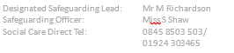
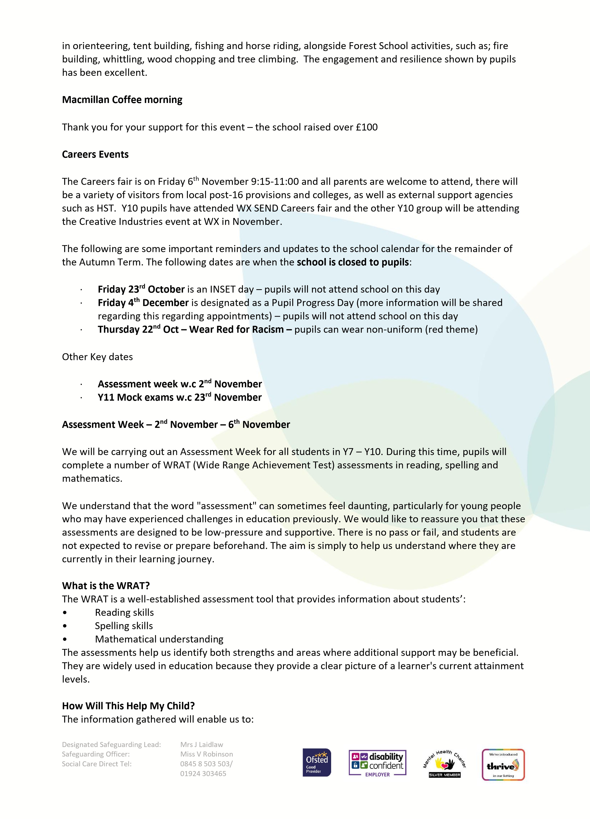



Designated Safeguarding Lead:

Mrs
J Laidlaw

Safeguarding Officer:

M
iss V Robinson

Social Care Direct Tel:

0845 8
503 503/

01924 303465

•

Further build an accurate academic profile for each student.

•

Identify strengths that can be celebrated and developed further.

•

Identify any gaps in learning that may need targeted support.

•

Plan interventions and personalised learning programmes.

•

Measure progress more effectively over time.

•

Ensure teaching is pitched at the right level for each individual.

As an SEMH provision, understanding the whole child is central to everything we do. Alongside the
relationships we build with students and our knowledge of their social, emotional and mental health
needs, these assessments provide valuable information that

helps us remove barriers to learning and
maximise opportunities for success.

How Will the Assessments Be Carried Out?

To ensure students feel comfortable and supported, all assessments will be completed 1:1 with a
Teaching Assistant. Students will be able to work at their own pace in a calm environment, allowing them
to demonstrate what they know and can do without the pr
essures often associated with formal testing.

For our Year 10 students, these assessments are particularly valuable as they move closer to important
qualifications and post
-
pathways.
16

The information will help us to:

•

Identify any further gaps in literacy or numeracy that may impact next steps

•

Put additional support in place before students enter Year 11.

•

Ensure appropriate intervention programmes are targeted where they are needed most.

•

Support planning for careers, college applications, apprenticeships and future employment
opportunities.

•

Ensure students leave us with the strongest possible foundation for their next steps.

By identifying areas of need early, we can provide the right support at the right time, helping students to
feel more confident and better prepared for the future.

Thank you for your continued support. If you have any questions regarding Assessment Week or the
WRAT assessments, please do not hesitate to contact Paul Carmody
, Assistant Head Teacher

who will be
able to
answer

any further questions.

I appreciate your continued support
regarding
the above.

Thank you for your understanding and cooperation. Should you wish to speak with a member of the
school team in the meantime, please do not hesitate to contact us
.

Yours sincerely,

Mark Richardson

Headteacher

